Open post-doctoral position
Houston*, TX, Baylor College of Medicine
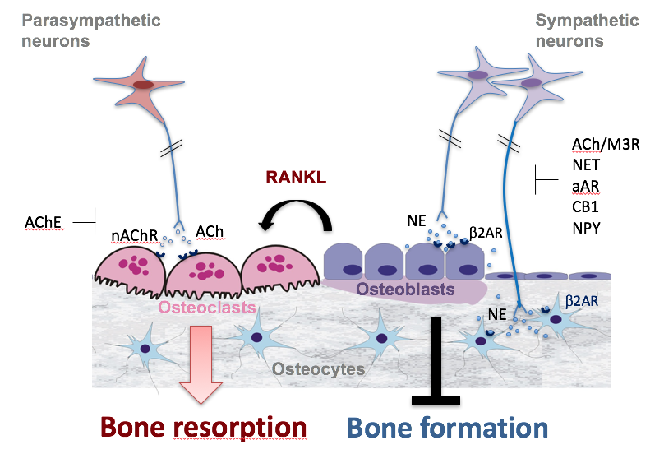

A post-doctoral position is available in the laboratory to investigate the mechanisms underlying the impact of the autonomic nervous system on bone homeostasis. This project is based on solid preliminary data and funded through the National Institute on Aging up to 2022. The laboratory currently hosts 3 post-doctoral fellows, 2 PhD students and two technicians.
The candidate is expected to be very engaged, pro-active and autonomous to drive his/her research project. He/she must be able to design research protocols independently, and to report plans and results on a weekly basis. He/she must demonstrate excellent skills in cell culture, molecular biology, histology/microscopy, transcriptional and protein analyses and mouse studies. A background in pharmacology or lineage tracing/microscopy is a plus.
*: Don’t be afraid of hurricanes, one just came by, the probability of another one hitting us within the next 5 years is not significant.

