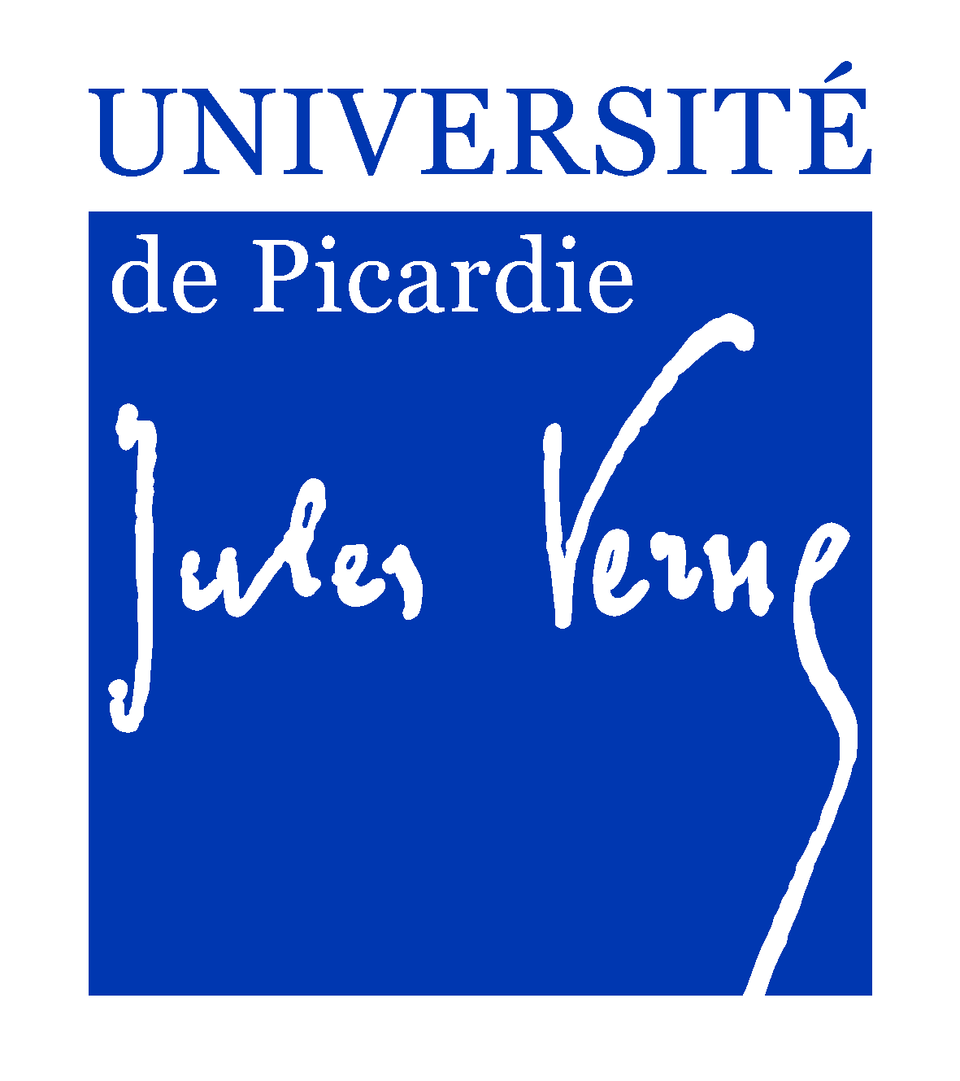
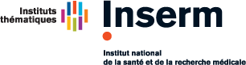

MP3CV, INSERM UMR-S 1088
Mécanismes physiopathologiques et conséquences des calcifications cardiovasculaires : rôles des remodelages cardiovasculaires et osseux.

Postdoctoral Fellowship
Amiens, France
This is a 1 year position.

Applications are invited for a Postdoctoral Fellowship position to work on pathophysiological mechanisms of CKD-MBD which designate the systemic disorder of mineral and bone metabolism due to CKD.

The Project: Chronic kidney disease is a global public health problem. The progressive loss of kidney function is invariably complicated by disorders of bone and mineral metabolism and cardiovascular disease, resulting in premature death. The project will test the hypothesis that uremic toxins which accumulate in CKD are implicated in CKD-MBD leading to impaired bone quality and mass, increasing fracture risk. The aims of this project are to:
(1) determine which uremic toxins impact bone marrow cells in a mouse model of CKD,
(2) establish how uremic toxins dysregulated bone remodeling in the development of CKD-MBD in uremic mouse,
These experiments will determine a new strategy for the treatment of CKD-MBD.

The Successful Candidate: We are seeking a highly motivated researcher with a PhD in biological or biomedical science, high quality publications in peer reviewed international journals. An experience in stem cells and mouse models would be an advantage.

The Setting: The successful candidate will join a collaborative group of researchers in the Centre Universitaire de Recherche en Santé (CURS) of the University of Picardie Jules Verne. The CURS is located in Amiens with a strong research environment and excellent facilities. It also benefits from its closeness to other research teams and University Hospital of Amiens, allowing for interactions and collaborations with number researchers and medical teams.

Prospective applicants are encouraged to contact Pr. Said KAMEL (email:said.kamel@u-picardie.fr).

